Regenerating Perennial Ryegrass – RPR, as strong as iron!
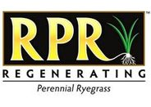
RPR is a self-regenerating perennial ryegrass that develops determinate stolons. RPR is the first perennial ryegrass variety with this particular quality. It stands up to heavy traffic while keeping its good looks. As a stoloniferous perennial ryegrass, RPR outperforms traditional perennial ryegrass, resulting in a regenerating perennial ryegrass with the highest wear tolerance: ideal for sports purposes.

About RPR

RPR was originally developed by Barenbrug and launched in the USA in 2010, where it was an immediate hit for sports fields. It was even awarded the famous Innovation Award at the STMA show in the USA. RPR was introduced in Europe in early 2012; first in the Dutch market, followed by other countries including Belgium, Germany, Denmark, Sweden, the Czech Republic, Poland, Italy and Romania.
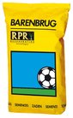
RPR Sport
Perennial ryegrass is often used for sports fields that face heavy action. Nonetheless, people want a perfect pitch every single time. To make this happen, the grass must be strong and self-regenerating. Perennial ryegrass is a good option, but RPR is an even better one. Extremely fast recovery and a pitch as strong as iron are guaranteed with RPR.
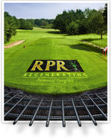
RPR Golf
High wear tolerance, minimal damage and extremely fast grass recovery are ideal features for a golf course. Super-strong Barenbrug RPR mixtures are the perfect choice for golf courses. These mixtures were used on golf courses during the golf tour instead of the usual ryegrass.

Below you will find two of our RPR golf mixtures that are as strong as iron!
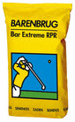  Bar Extreme RPR  Bar Extreme RPR is a 100% fine-leaved perennial ryegrass mixture with RPR that ensures extremely quick recovery and is super-strong. It produces a high-quality golf course that minimises damage. It is mainly used for reseeding. | 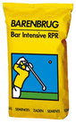  Bar Intensive RPR  Bar Intensive RPR is a tee and fairway mixture consisting of red fescue and fine-leaved perennial ryegrass to which RPR has been added. This has resulted in a strong mixture that, thanks to the red fescue, has a high disease tolerance, a high wear tolerance and an extreme dense sward. Bar Intensive RPR is used for both seeding and reseeding.

RPR performed above all expectations on our training complex. This made us decide to use it in the stadium as well. With simply outstanding results!”
Roy Rigby, Head Groundsman, Manchester City FC (UK)
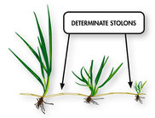
“Some things you have to see with your own eyes to believe them. Stoloniferous perennial ryegrass was one of those things for me – I am now a believer. Combining a creeping growth habit with the inherent capability to establish quickly and tolerate wear has the potential to take this grass species to a new level.”
Dr. Andy Newell, Head of Turfgrass Biology, STRI Bingley (UK)

“We used RPR to rebuild a tee box last year and loved it. We have put a plan into place to overseed all our tees with RPR because of its great performance.”
Gary Lindsey, Superintendent, Vermillion Fairways Golf Course, Cook, Minnesota USA

